**Interest Rate Risk Analysis Procedure**

**Sept 2021**

|  |  |  |  |
| --- | --- | --- | --- |
| **Version** | **Date Changes Made** | **Author** | **Description of Changes** |
| Original | 09/05/2018 | Angelina Zhou/Kexiang Xiang | Creation |
| V2.0 | 3/31/2020 | Angelina Zhou/Harry Guo | 2020 annual review |
| V2.1 | 9/10/2020 | Harry Guo | Added ABAC and IRSRS sample report |
| V2.2 | 9/10/2021 | Harry Guo | Annual review. Added significant risk section |

|  |  |
| --- | --- |
| **Identifying Information** |  |
| **Title** | Interest Rate Risk Analysis Procedure |
| **Procedure Owner** | TRY |
| **Contact Information** | Adrian Xin Long /Harry Guo |
| **Effective Date** | Sept 2021 |
| **Location** | BOCNY Library and J:\1. Policy, Procedure & Plan\2. TRY Procedures |
| **Document Type** | Procedure |

|  |  |  |  |
| --- | --- | --- | --- |
| **Reviewed by** |  | | |
| **Harry Guo, SVP of Treasury** |  |  | 9/10/2021 | |
| Signature |  | Date: | |

|  |  |  |  |
| --- | --- | --- | --- |
| **Approved by** |  | | |
| **Charlie Peng, SVP & Head of Treasury** |  |  | 9/21/2021 |
| Signature |  | Date: |

Contents

1. Executive Summary 4

1.1. Rationale 4

1.2. Related Policies & Procedures 4

2. The Scope 4

3. Roles & Responsibilities 4

3.1. Procedure Governance & Implementation 4

4. Procedure Instructions 5

4.1. Summary 5

4.2. Procedures 5

4.3. Key Assumptions 11

4.4. Significant Risk Event and Exposure 11

5. Procedure Assurance Methods 12

5.1. Awareness Methods 12

5.2. Training Methods 12

5.3. Update Requirements 12

5.4. Consequences of Violating the Procedure 13

5.5. Glossary 13

6. Reference 13

1. Executive Summary

The purpose of the Interest Rate Risk Management Procedures (“procedure”) is to outline the Treasury’s (“TRY”) role, responsibilities and operational procedure to support the interest rate risk measurement process for the Bank of China New York Branch and its satellite branches (collectively “the Bank” or “BOCNY”).

* 1. Rationale

Interest rate risk is the risk that future changes in interest rates will affect the bank's net interest income or earnings and market value. The goal of our interest rate risk management is to minimize the impact of interest rate volatility on current earnings and market value. The basic tools for the bank to monitor the interest rate risk exposure are the gap analysis, earnings and market value sensitivity modeling. The Bank sets its policy limits on net interest income (NII) at risk over one-year horizon and the economic value of equity (EVE) risk for a 200 bps parallel and immediate shock scenario.

* 1. Related Policies & Procedures

Related policies and procedures include the Bank’s Risk Governance Framework and the Market Risk Management Policy [1].

1. The Scope

The scope of the procedures is limited to the activities within TRY to support the measurement of interest rate risk, in particular, the metrics NII risk and EVE risk (Net Interest Income and Economic Value of Equity at Risk respectively). The procedure also refers to the derivation of a repricing gap of the current balance sheet. The repricing gap is used as a management guidance tool only and is not part of the Risk Appetite Statement. This procedure is a very high level description. More details of the methodology, assumption and analysis can be found in the BOCNY model documentation of Interest Rate Risk management system (PROFITstar 2018)[2].

1. Roles & Responsibilities
   1. Procedure Governance & Implementation

The risk governance framework and the market risk policy lay out the governance structure for interest rate risk including roles and responsibilities, the risk appetite statement, the lines of defense, the risk management process and the governance and communication of policies and procedures.

1. Procedure Instructions
   1. Summary

1. The repricing gap gives a rough estimate of the impact of interest rate changes on net interest income. The Bank uses the interest sensitivity analysis to manage net interest income fulfillment and optimize the structure of asset and liabilities by avoiding or minimizing the interest rate risk.

2. The analysis requires reliable information on the amount and timing of every account. A gap analysis report provides a measurement of repricing timeframe of assets and liabilities. The report cites timeframe over specified time intervals: Monthly in the first year, Quarterly for the second year, over 2 years and all other. Assets and liabilities are allocated by time horizon and amount, so that each segment will be subject to the related interest rate change. Much effort is expended on the identification of the detail appropriate for repricing time intervals because the accuracy of the balance sheet allocation will produce a more useful gap report.

3. The analysis basically applies repricing rates (for the floating rate items), and maturity rates (for fixed rate items) within discrete time periods or buckets. For each period, total liabilities are subtracted from the total assets. The formula may be defined as rate sensitive asset minus rate sensitive liabilities equals the interest rate sensitivity gap.

4. If the gap is a negative number, the balance sheet is said to be liability sensitive; if positive, the balance sheet is said to be asset sensitive. Generally, the Bank’s gap position will indicate how directional changes in interest rates will affect net interest income.

Based on RMICC's request, the Interest rate banking account risk will be reported to both ALCO and RMICC.

5. Frequency: Monthly, to be completed around the 10th business day of the following month

* 1. Procedures

4.2.1. The Interest Rate Sensitivity – Repricing Schedule Report includes branches of New York, New York I.B.F., Queens, Los Angeles, Los Angeles I.B.F, Chicago, Chicago I.B.F.

4.2.2. Source of Data: Data Obtained: Purpose of Data

(1) T24 Trial Balance Balance Sheet Preparation

(2) OPICS D/L Trial Balance Rollover Schedule Preparation

4.2.3. Tools: Data Sources Purpose

• Crystal report T24 Data Extraction

• PROFITstar T24 & Opics Interest Rate Sensitivity Analysis

• Excel N/A Worksheet Preparation

PROFITstar is an asset liability management tool from the third party vendor, Jack Henry & Associates Inc., and has been in operation in Bank of China US Branches since 1997. TRY follows the <<BANK OF CHINA US BRANCHES ANTI-BRIBERY & ANTI-CORRUPTION COMPLIANCE PROCEDURE>> on the vendor risk management. TRY also participate any ABAC training.

4.2.4. Report Preparation:

(1) TRY prepares several Interest Rate Risk Sensitivity reports utilizing the same base data but differing in interpretation and accounts distribution. These are:

• BOCNY ALCO package, including Interest Rate Sensitivity report, NII sensitivity analysis and EVE sensitivity analysis.

• HO reporting, including G33 Interest Rate Sensitivity report and IFRS Interest Rate Sensitivity data collection.

(2) As mentioned above, our management tool for IRR is the Interest Rate Sensitivity – Repricing Schedule (IRSRS), see sample report below. The first column of the IRSRS is simply the side headings from a condensed balance sheet. The last column is simply the totals for each category. The first and last column make up a regular balance sheet, and the numbers in between these 2 columns represent the rate sensitivities of the Bank’s assets and liabilities.

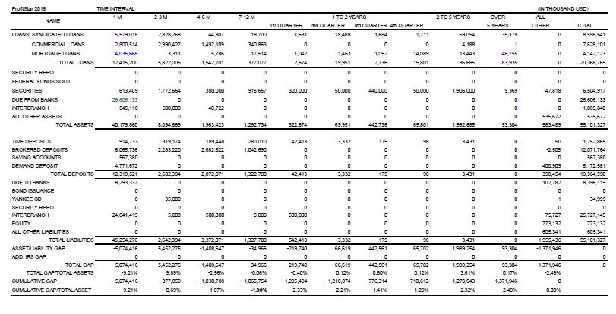

(3) After the IRSRS has been finished, the calculation of Earnings at Risk– Percentage of Net Interest Income will also be completed. The Calculation of Earnings at Risk demonstrates how net interest income can be influenced by changes in interest rates. Here the Bank takes an increase of 200 Basis Point assumptions: in order to analyze net interest income exposure.

(4) The Interest Rate Sensitivity – Repricing Schedule Report of the Bank has the following characteristics:

• It is based on month-end balances.

• It reflects stated maturity of fixed-rate items, as well as revolving-rate, floating-rate items accounts.

• It includes any effects resulting from swaps on banking book hedges.

• It shows two ways of “gap”: One, on an individual basis for each period; Two, on a cumulative basis, and the cumulative gap of total balance is zero.

(5) Lastly, the analysis will compare the Bank’s gap position in a given period with predicted interest rate levels. The result is a framework for estimating the effect of this relationship on net interest income. Gap analysis can provide a basis for deploying tactics. The Bank will treat it as a useful tool in trying to manage net interest income. For example if rates are perceived to be rising, the gap is characteristically altered by converting fixed-rate assets into variable-rate assets and variable-rate liabilities into fixed-rate liabilities. This results in higher asset interest-rate sensitivity. The implication is that the Bank has an increasing opportunity to reprice assets and thereby take advantage of higher pricing resulting from higher rates.

4.2.5. IRR Procedure via PROFITstar

The Bank uses PROFITstar to prepare its management reports.

The starting point for the preparation of the PROFITstar management reports is the reconciliation of the PROFITstar balance sheet to the T24 balance sheet in order to ensure that the information used is consistent with official Bank records. The PROFITstar balance reports are prepared on a monthly basis.

(1) Obtain PROFITstar download files from ADC. These files are: FMD_GL, FMD_Loan, FMD_DDA, FMD_DEP, PROFITstar_Bond, PROFITstar_CD, PROFITstar_Loan. upload these download files into PROFITstar via Move and Link process.

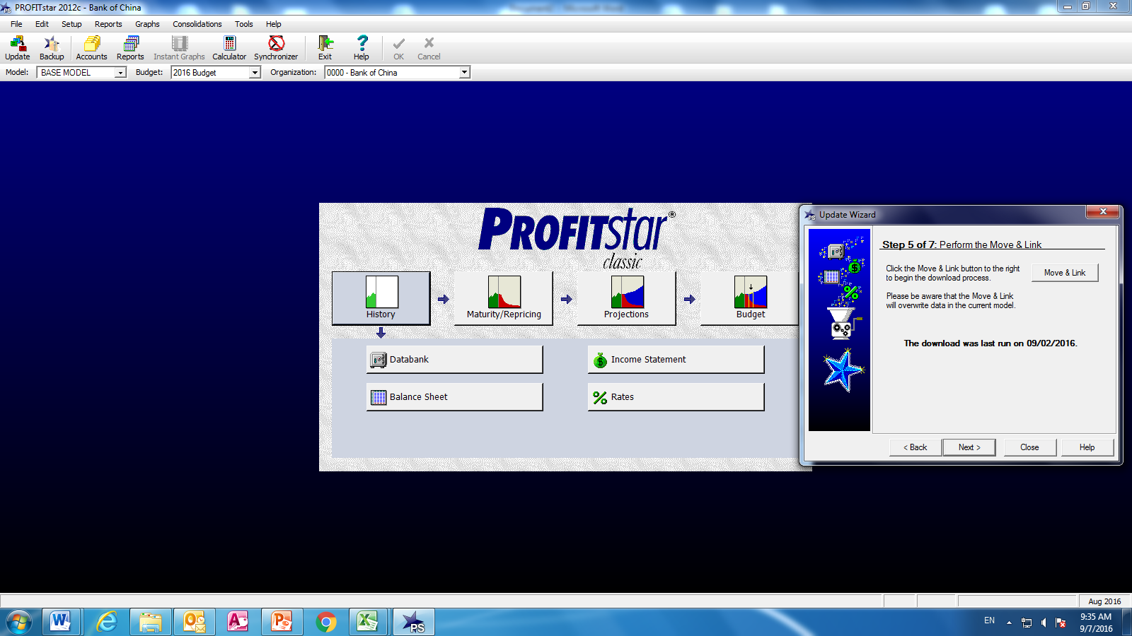

(2) Reconcile the consolidations.

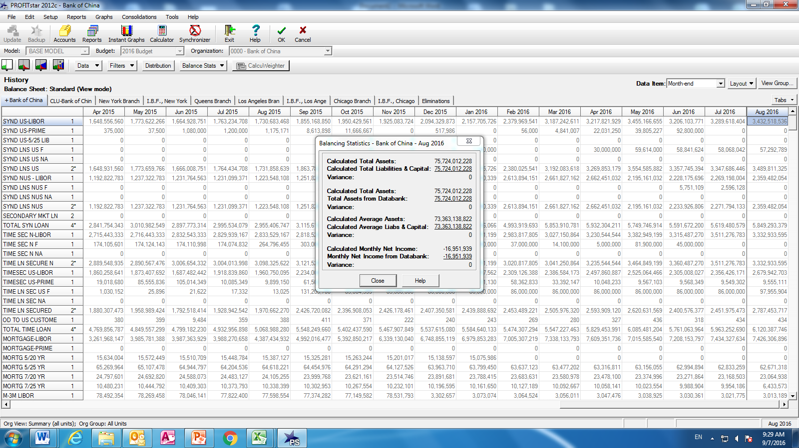

(3) Auto update the Maturity and Repricing model.

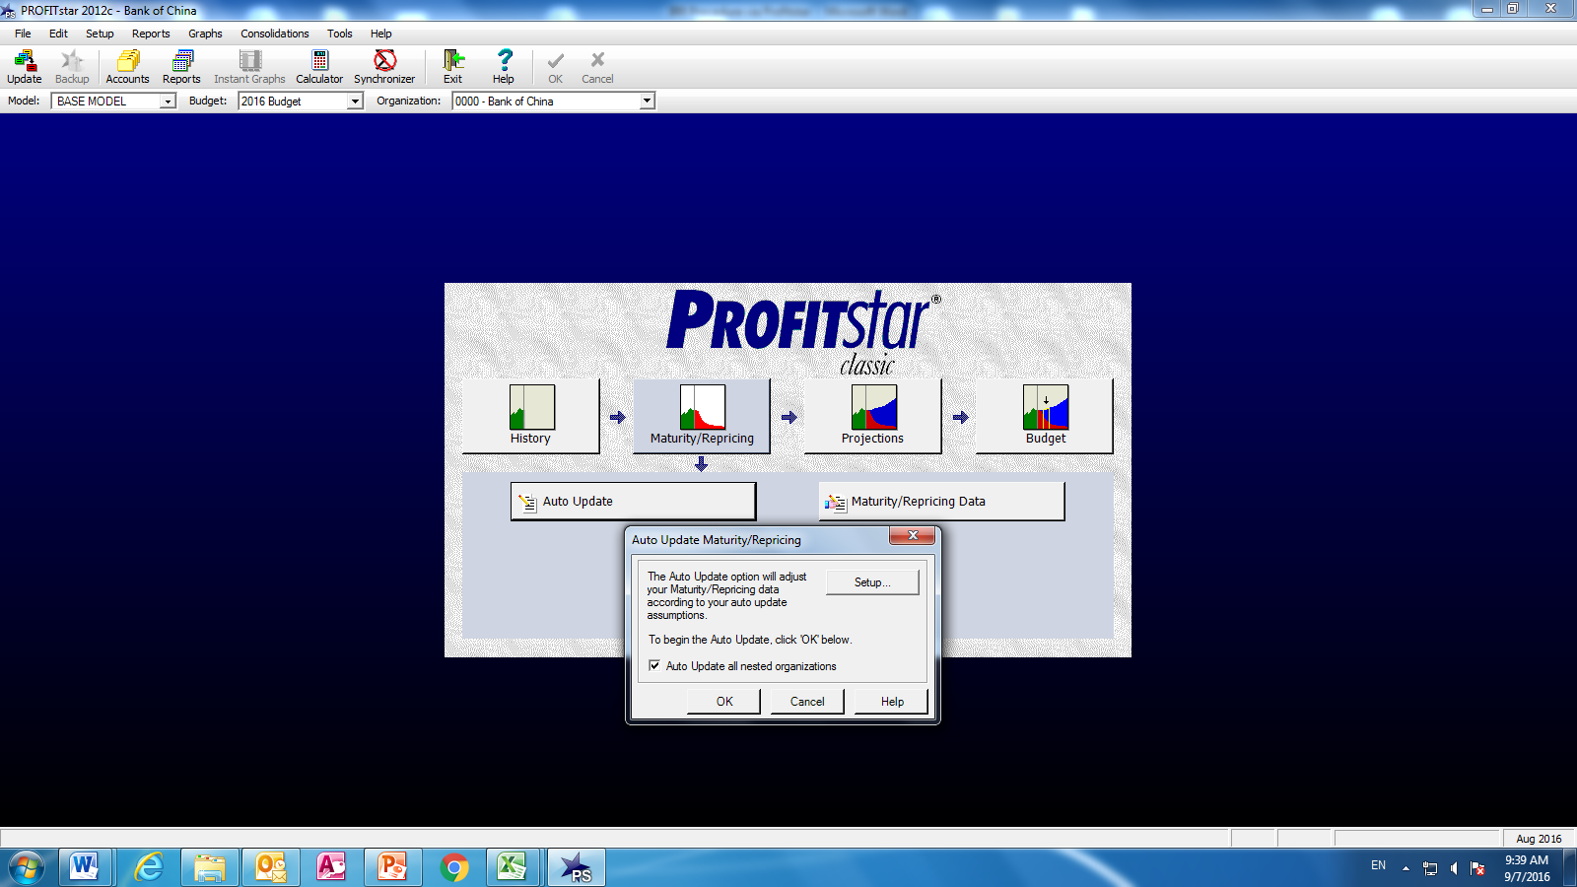

(4) Check the Balancing statistic in M/P model.

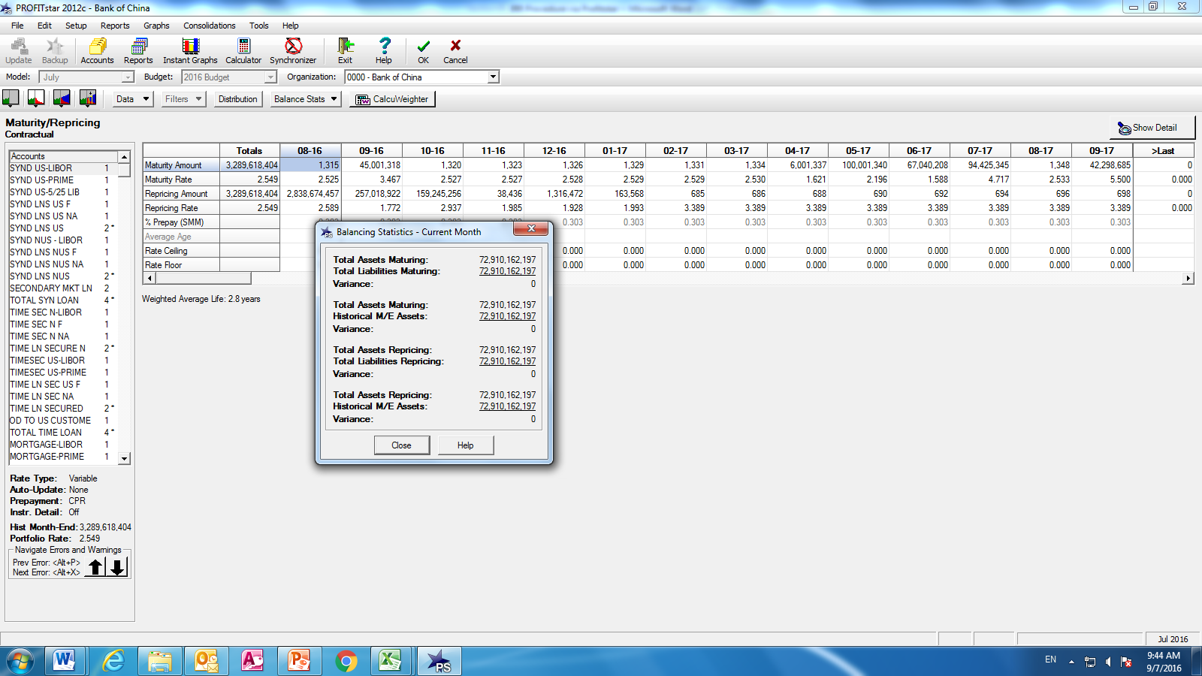

(5) Update the Projections Model with annual or semi-annual assumptions.

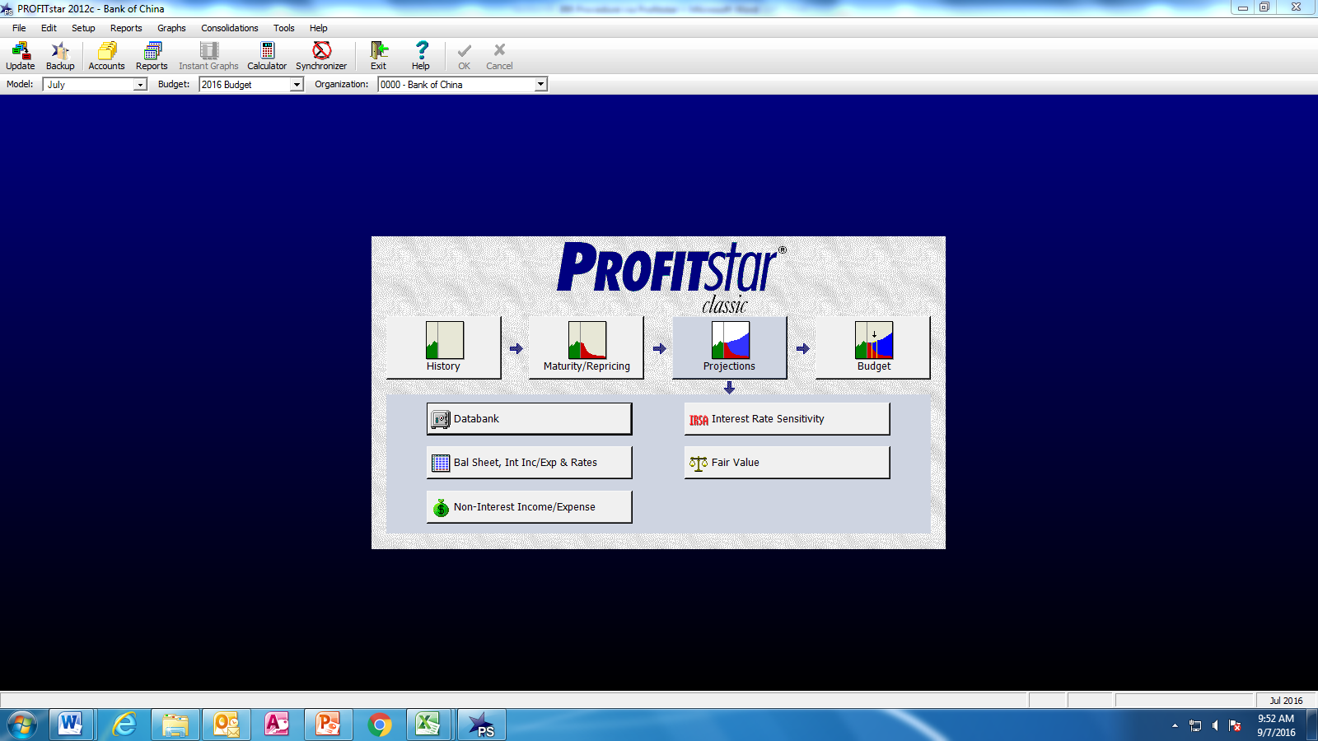

(6) Auto calculate the Interest Rate Sensitivity matrix and FV Matrix by clicking the button.

(7) Go to the Report Wizard_Risk Analysis_IRSA Matrix to get the IRR report. Use the same wizard but selecting the Fair Value Matrix to obtain the EVE report.

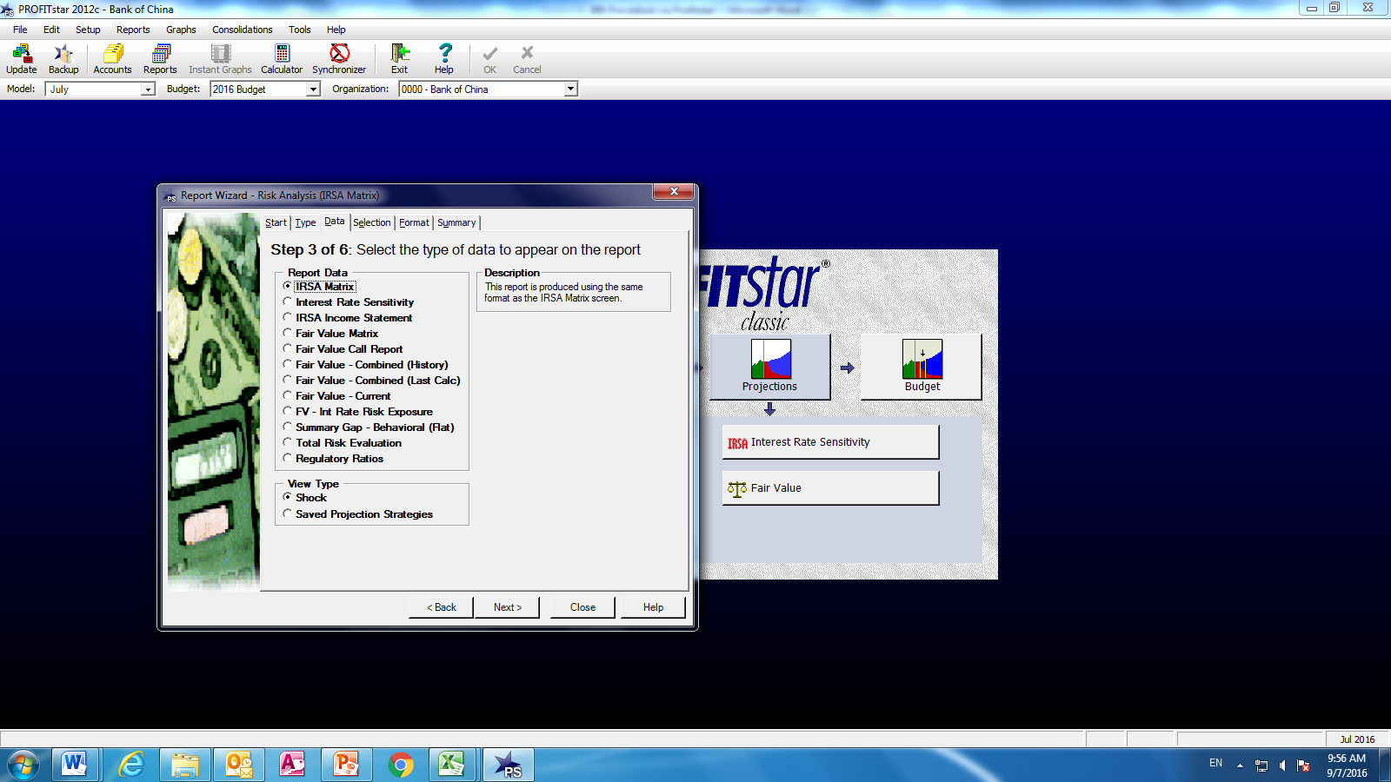

* 1. Key Assumptions

Based on the market risk policy and methodology, TRY maintains a set of assumptions implemented in the PROFITstar and updates them as needed. The assumptions are reviewed by MRD and approved by EVP in charge at least annually or as necessary. The set of assumptions includes but is not limited to:

* Offering rate
* Prepayment ratio
* Beta assumption
* Decay assumption
* Key rates trending
* Balance sheet projection
  1. Significant Risk Event and Exposure

TRY monitor, escalate and develop action plan and solution on significant risk event and risk exposure, including but not limited to

* Breaches to the regulatory requirement on interest rate risk
* Major changes/adjustments to the asset-liability strategy and structure, which may significantly impact interest rate risk
* Policy changes or market movements which may have major impact to the bank’s financial and operation

TRY will estimate the risk impact and, depending on the risk level and nature, timely report to EVP in charge, and / or escalate to other executive management or HO when necessary. Furthermore, TRY will coordinate with other departments, when necessary, to develop action plan and resolutions to mitigate and remediate the risk, and report the results to executive management and/or HO.

1. Procedure Assurance Methods
   1. Awareness Methods

Interest rate risk reports are provided to the ALCO, and the KRI details are reported to MLRC, and in dashboard format to the RMICC and the USRMC. The procedure is also uploaded to BOCNY’s library of policies and procedures.

* 1. Training Methods

This procedure is saved to the TRY shared folder, BOCNY’s library of policies and procedures, and is communicated with all TRY members. This procedure is also used as training material for new hires and meetings may be hold to discuss any questions which may be raised. Any material changes to the procedure will be communicated to all relevant TRY members and other stakeholders.

* 1. Update Requirements

Following Policy on Policies & Procedures of ORD, this procedure will be reviewed periodically for potential updates or approvals at least every three (3) years or more frequently when necessary to address potential trigger events.

Trigger events may include but not limited to new or updated policies the procedure supports, methodology or product coverage change, regulatory examination findings, audit findings, system or process changes, merger or divestiture or other major business event.

* 1. Consequences of Violating the Procedure

The consequences of violating the procedure are manifold, including reporting and processing errors which in turn will affect the performance evaluation of the responsible members of the staff and hence the entire department. Delays and or errors in reporting may potentially have regulatory and reputational impact.

* 1. Glossary

|  |  |
| --- | --- |
| Abbreviation | Full Name |
| BOCNY | BOC New York and satellite branches |
| TRY | Treasury |
| ALCO | Asset Liability Management Committee |
| MLRC | Market and Liquidity Risk Committee |
| RMICC | Risk Management and Internal Control Committee |
| USRMC | US Risk Management Committee |

1. Reference
2. BOCNY MRD, BOCNY Marker Risk Management Policy, June 2020
3. BOCNY TRY, Model documentation of Interest Rate Risk management system (PROFITstar 2018), Sept 2021